Week-2
Insurance database additional queries
1. Display the entire car relation in ascending order of manufacturing year.
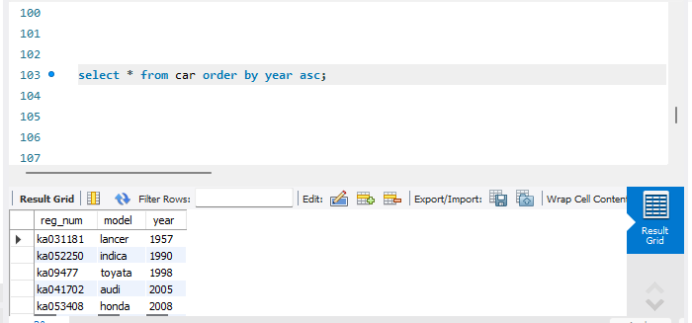
2. find the number of accidents in which cars belonging to a specific model (example ‘lancer’) were involved.
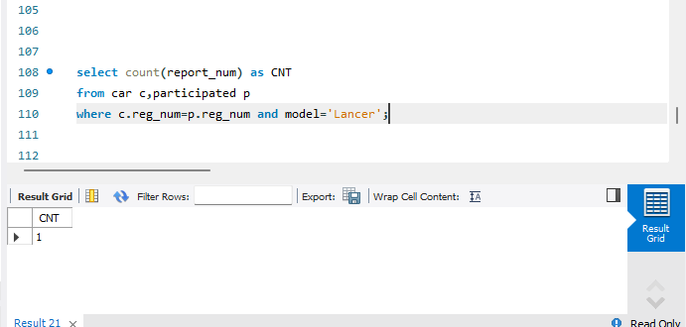

3. Find the total number of people who owned cars that involved in accidents in 2008.
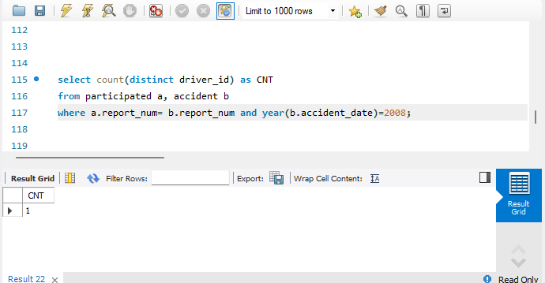
4. list the entire participation relation in the descending order of damage amount.
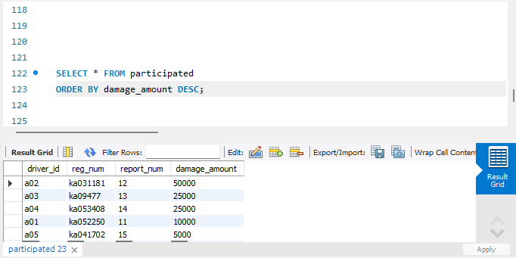
5. find the average damage amount.
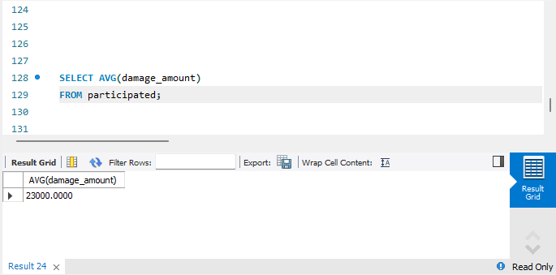
6. delete the tuples whose damage amount is below the average damage amount.
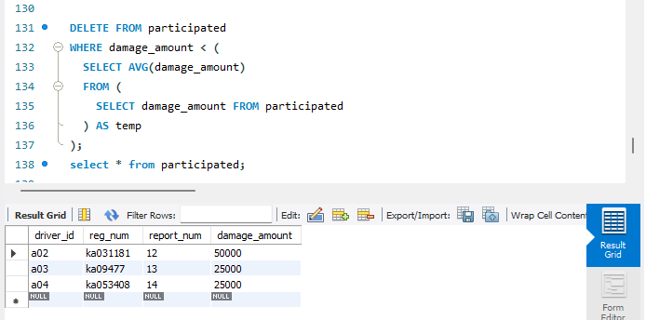
7. list the names of drivers whose damage is greater than the average damage amount.
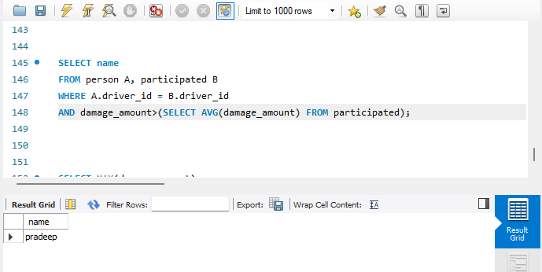
8. find the maximum damage amount.
